KC Luczko  
8/22/2025  
Professor Wang  
CS1300   
  
**PART A COMPUTING RESEARCH**  
  
**Hardware** is the physical components of anything but in this instance we are talking about computer components like the CPU,Motherboard,GPU,RAM, and Power supply. Hardware is the machine's power and components that allow software to execute programs and applications.

**Software** refers to the programs, applications, and data that tells the hardware what to use the processing power on. Some good examples are operating systems, applications like firefox, Microsoft word, and finally drivers. Drivers are really important to keep the computer secure and updated to fix glitches that impact the systems performance.  
 **Hardware examples**  
**Center processing unit or better known as the cpu**. The CPU is considered the brain of the computer that handles processing instructions from programs and operating systems.  
  
**Random Access Memory (RAM)** Ram temporarily stores data to keep it quickly available but once the PC is shut down it loses the stored data.

**SSD/ HARDRIVES**. This is the permanent storage for the operating system, applications, and files.  
  
**Software examples**  
**Operating systems** (Windows,Linux, macOS) operating systems manage hardware resources and give the user an interactive interface.

**Web browsers** Chrome,firefox,edge,brave,opera,etc) These applications allow users to access websites and discover the web.  
**Word Processor** (Google docs, Microsoft word, Notepad) these processes help you create, edit and format documents.

**How they work together.**Hardware provides the physical components, while software provides the instructions. For example, when you click to open a file in file explorer, the cpu processes the request, the RAM stores the active data from the request, and the ssd/hard drive retrieves the file from the permanent stored data. Without software hardware is pretty much useless but when they are used hand and hand they create something truly magical.

**Programming language investigation.**

**Java**

Uses: Enterprise software, android development, and most backend systems related to microsoft.

Strengths: Cross-platform, strong typing,scalable.  
Applications:Mobile apps, web servers, banking systems, and anything microsoft related

**Python**  
Uses: Web development,data science, and Artificial intelligence.  
Strengths: Large community, tons of public libraries, easier to learn then some languages.  
Applications: Small projects, machine learning, and simple scripts  
  
**C++**Uses: Game Development, System programming, applications that need a lot of resources.  
Strengths: High performance, and is super fast due to the low level memory control.  
Applications: Game engines, operating systems, embedded systems.  
  
**Why Python is Good for Beginners.**

Python has been considered the best language for beginners due to its simplicity and english oriented syntax. It's also super easy to read and has a massive community. Unlike C++ or Java, Python doesn't require deep knowledge of memory management or vast syntax knowledge to start coding entry level programs.  
  
**Career Exploration.  
  
Software Developer**Skills: Proficiency in multiple coding languages like (Python, Java, C++, etc), Debugging, and working as a team.  
Responsibilities: Designing the programs structured, as well as writing and maintaining software applications.  
Programming style/fit: You cannot go into this field without coding.

**Data Scientist**Skills: Statistics, Python, data visualization, machine learning, excel.  
Responsibilities: Analyzing large datasets to find insights and create prediction based models.  
Programming style/fit: Uses less coding than software development but still needs some knowledge.

**Cyber security Analyst**

Skills: Networking, ethical hacking abilities, scripting mainly using bash and python, and problem solving.  
Responsibilities: Monitoring systems to protect it from threats and breaches through the fire walls.  
Programming style/fit: Automation of scripts, breach tests and malware prevention/analysis so coding is pretty much a staple in this career.  
  
Python Environment  
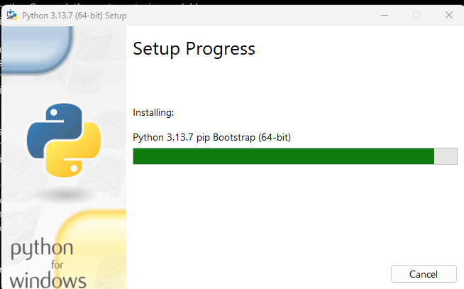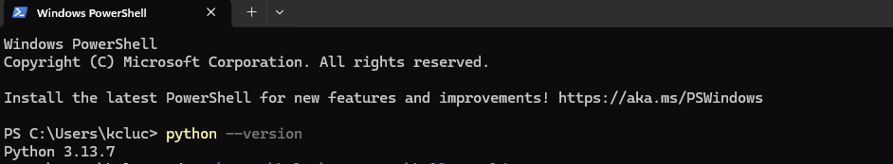  
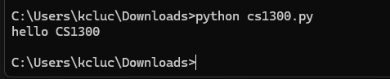  
  
  
**VSCode Exploration**

Step 1 download visual studio code at <https://code.visualstudio.com/>  
Step 2 install and launch

Step 3 Execute the file.  
Menu options  
Click file in the top left then you can select Open folder/ New file/ Run without debugging and so many more.   
Useful features  
Terminal: VS code has a built-in terminal that can run multiple coding languages.  
Syntax highlighting by changing key words a different color  
VS code will auto fill in some suggestions for functions and variables.  
VS code also has a built in debugging tool which is super handy when you have errors in the code.  
Save and running a file.  
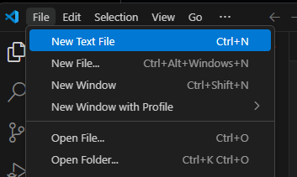Then select SAVE AS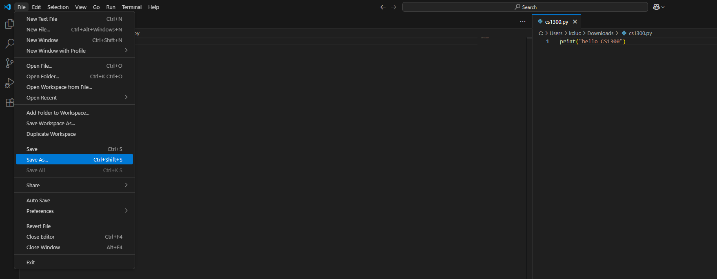

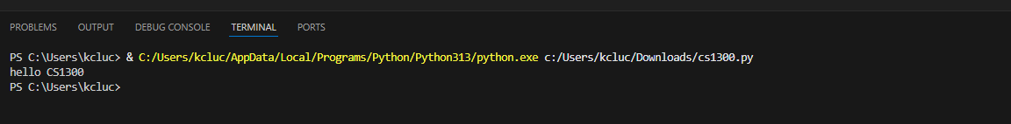  
  
  
  
  
**First Programs**KC Luczko test [script.py](http://script.py) this prints hello world  
KC Luczko number [guessinggame.py](http://guessinggame.py) creates a fun little guessing game.  
KC Luczko [calculator.py](http://calculator.py) is a working 2 number addition calculator.